CALL TO ARTISTS – REQUEST FOR PROPOSALS
Greenville Mural Project
Various Locations in Uptown Greenville
Applications Due: October 21, 2019

Project Description & Objective
The newly formed Greenville Mural Project, comprised of staff of the Pitt County Arts Council at Emerge, Greenville-Pitt County Convention & Visitors Bureau (Visit Greenville, NC), Uptown Greenville, East Carolina University, and members of the community invite visual and graphic artists to apply for the opportunity to submit proposals and qualifications for public art projects at various locations in the Uptown Greenville and Dickinson Avenue Districts.

The goal of the Greenville Mural Project is to facilitate the creation and execution of murals and public art installations in Uptown Greenville and the surrounding neighborhoods.
Our Phase 1 goal is to complete at least three new murals by December 1, 2019.
Three Phase 1 mural locations have been identified and secured by the Greenville Mural Committee, please submit design for one or more of the following: *See Page Three for photos of designated mural locations*

1. Design for Vinyl Wrap of Utility Box in Uptown Greenville:
Utility Box #1 Location: Fifth Street & Cotanche Street and Evans Street
Dimensions:
Width: 37.00" Height: 73.00" (2 North/South panels)
Width: 26.50" Height: 73.00" (2 East/West Panels

2. Design for Vinyl Wrap of Utility Box in Uptown Greenville:
Utility Box #2 Location: Reade Circle & Cotanche Street
Dimensions:
Width: 37.00" Height: 63.00" (2 North/South panels)
Width: 26.50" Height: 66.00" (2 East/West Panels)

3. A Time for Science- Greenville
Location: 729 Dickinson Avenue, Greenville NC 27834
Dimensions: Width: 52” Height: 16”

Three finalists will be chosen and will receive a $500 Honorarium for their design which will be reproduced at one of the three mural proposal at one of the three mural locations. Funding for implementing the selected murals will be provided by the Greenville Mural Committee and partners.

ELIGIBILITY
Open to any artist or designer.

PROJECT TIMELINE
Applications Due: October 21, 2019
Finalists Selection: October 21 – 25, 2019
Installation: November 2019

HOW TO APPLY:
All necessary files must be submitted no later than Monday, October 21, 2019, via https://pittcountyarts.org/artists/artistopportunities.

ARTISTS MUST SUBMIT THE FOLLOWING:
- Project Statement: No more than 1 page including your background and why you should be chosen for a Greenville Mural Committee Project mural

- Artist Resume: No more than 3 pages, including contact information

- 5 Work Samples: showcasing your style and artistic merit. Previous mural experience is not required, but encouraged

- 3 References: 3 references with names, titles, addresses, emails, and phone numbers

EVALUATION
Three finalists will be chosen based on the final criteria:
- The merit of the work samples
- Proven experience to execute exterior murals
- Artists are willing to collaborate with the Greenville Mural Project team and selected location partners to create a mural that responds to the context of the community

ADDITIONAL INFORMATION
For questions, contact, please contact:

Holly Garriott, Executive Director of the Pitt County Arts Council at Emerge
Email: holly@pittcountyarts.org | Phone: 252-551-6947

Sierra Jones, Director of Communications & Marketing for Visit Greenville, NC
Email: sierra@visitgreenvillenc.com | Phone: 252.329.4200 ext. 4248

1. Design for Vinyl Wrap of Utility Box in Uptown Greenville:

Utility Box #1
Location: Fifth Street & Evans Street
Dimensions:
Width: 37.00" Height: 73.00" (2 North/South panels)
Width: 26.50" Height: 73.00" (2 East/West panels)

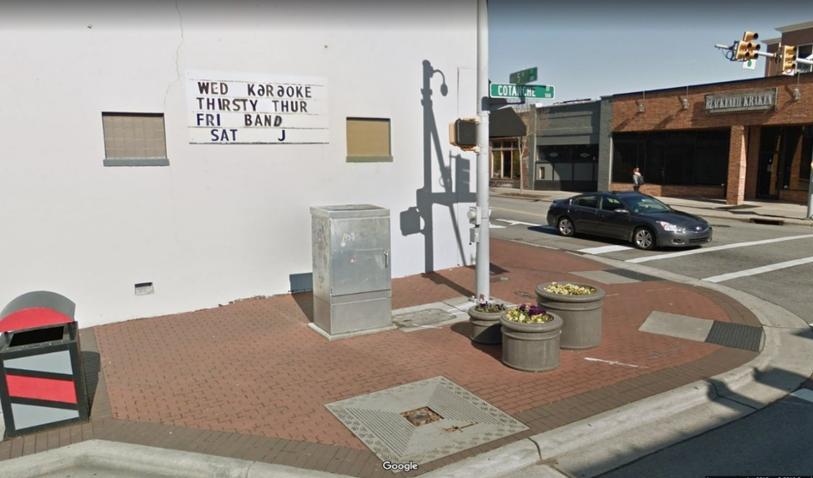

2. Design for Vinyl Wrap of Utility Box in Uptown Greenville:

Utility Box #2
Location: Reade Circle & Cotanche Street
Dimensions:
Width: 37.00" Height: 63.00" (2 North/South panels)
Width: 26.50" Height: 66.00" (2 East/West panels)

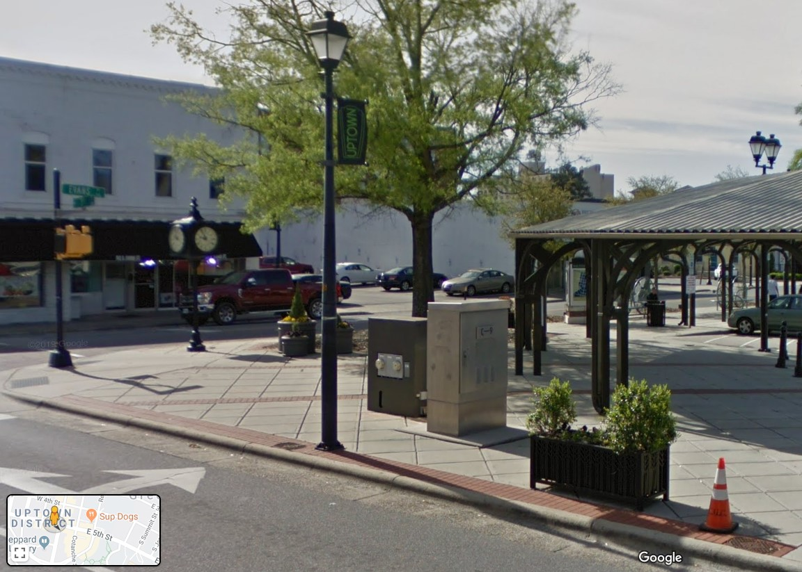

3. A Time for Science- Greenville
Location: 729 Dickinson Avenue, Greenville NC 27834
Dimensions: Width: 52” Height: 16”

